**Installing JDK 1.8:**

Visit : <https://www.oracle.com/java/technologies/downloads/#java8-windows>

Click on highlighted link to download:

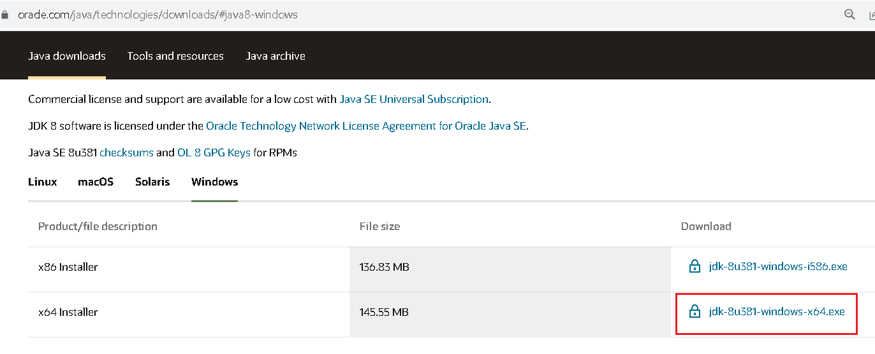

Run the exe!

**Installing Eclipse:**

JDK 1.8 is not compatible with latest versions of Eclipse. Recommended versions are Neon and Oxygen:

Visit: <https://www.eclipse.org/downloads/packages/release/neon/3>

Choose highlighted options:

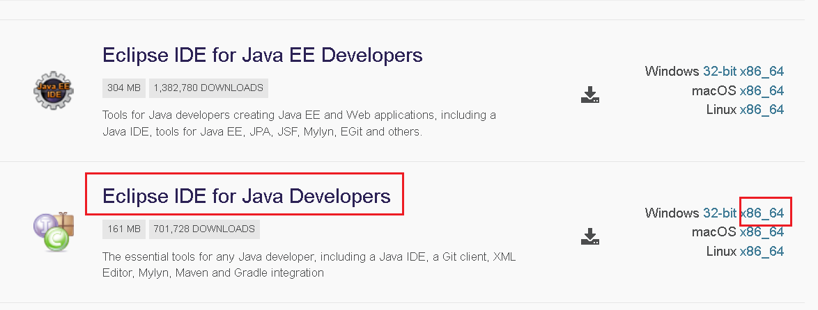

You will get a zip file. Simply unzip it. There is NO installation!!